# Project group 13

•Report:

• Overview of the study:

1. **Overall duration:**

December 7, 2022, 06:47:03 (UTC-05:00) - December 7, 2022, 23:51:25 (UTC-05:00) Himanshi,

December 7, 2022, 00:51:37 (UTC-05:00) - December 8, 2022, 01:37:25 (UTC-05:00) Pavan,

December 6, 2022, 23:53:28 (UTC-05:00)- December 7, 2022, 23:50:50 (UTC-05:00) Hrushikesh,

December 7, 2022, 22:24:40 (UTC-05:00)- December 8, 2022, 22:27:09 (UTC-05:00) chaitanya

1. **AWS S3 bucket number:** sensus3-e94d8409-36d5-4043-ba49-7b59e14b8ef7
2. **Total data size:** 1.30 MB (13,72,160 bytes)
3. **Protocol screenshots on start:**

* Himanshi

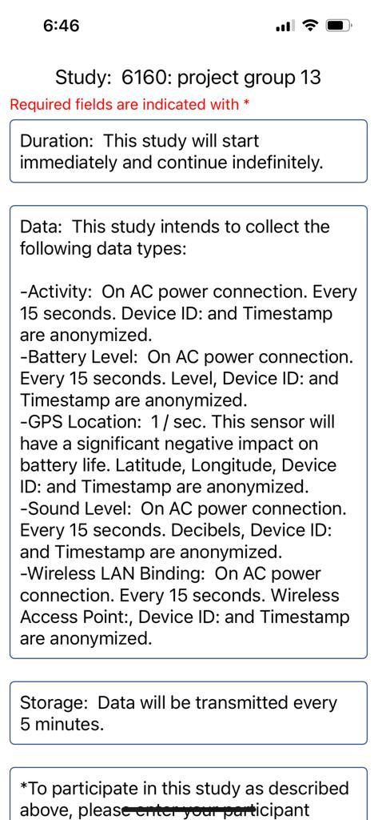

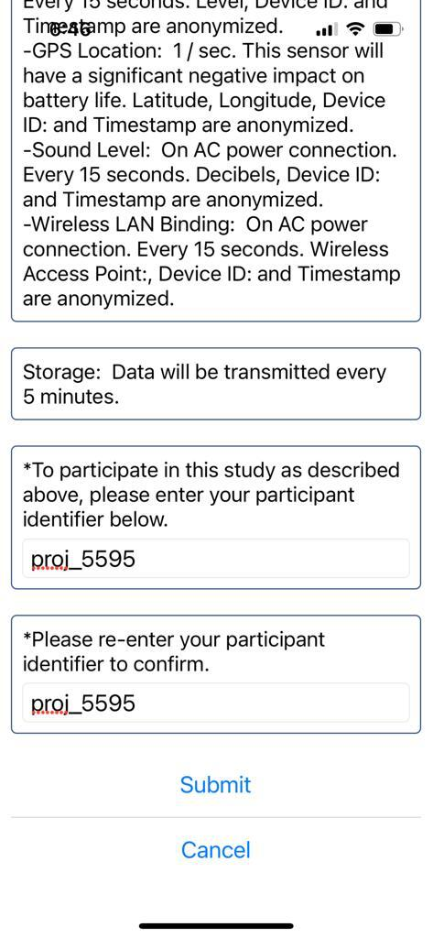

* Pavan

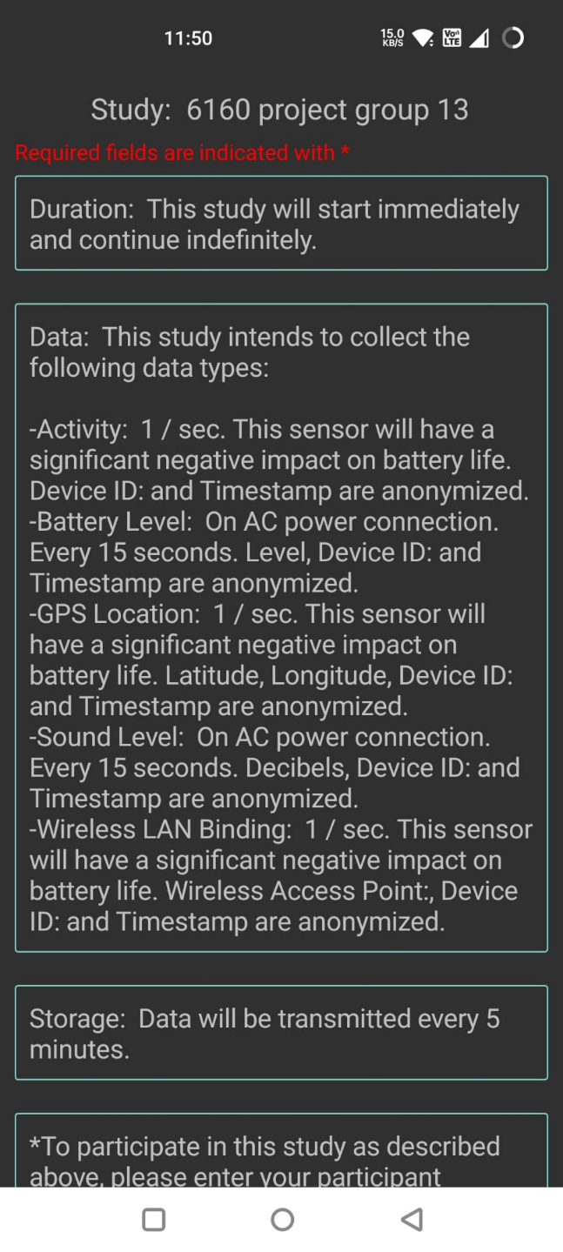

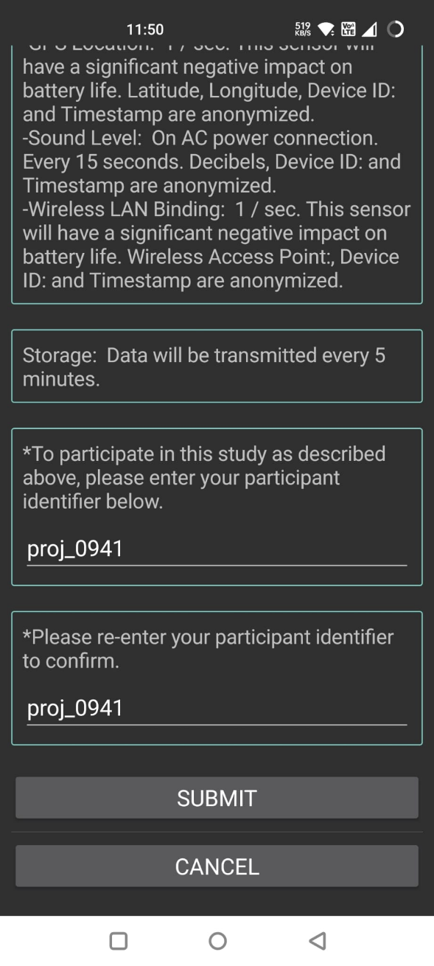

* Chaitanya

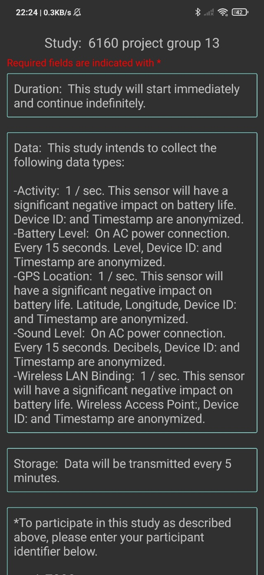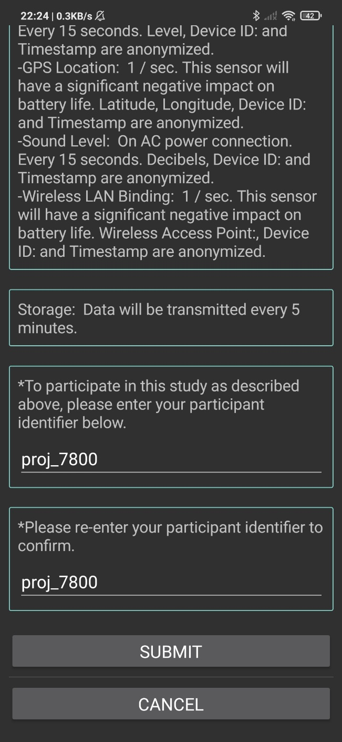

* Hrushikesh

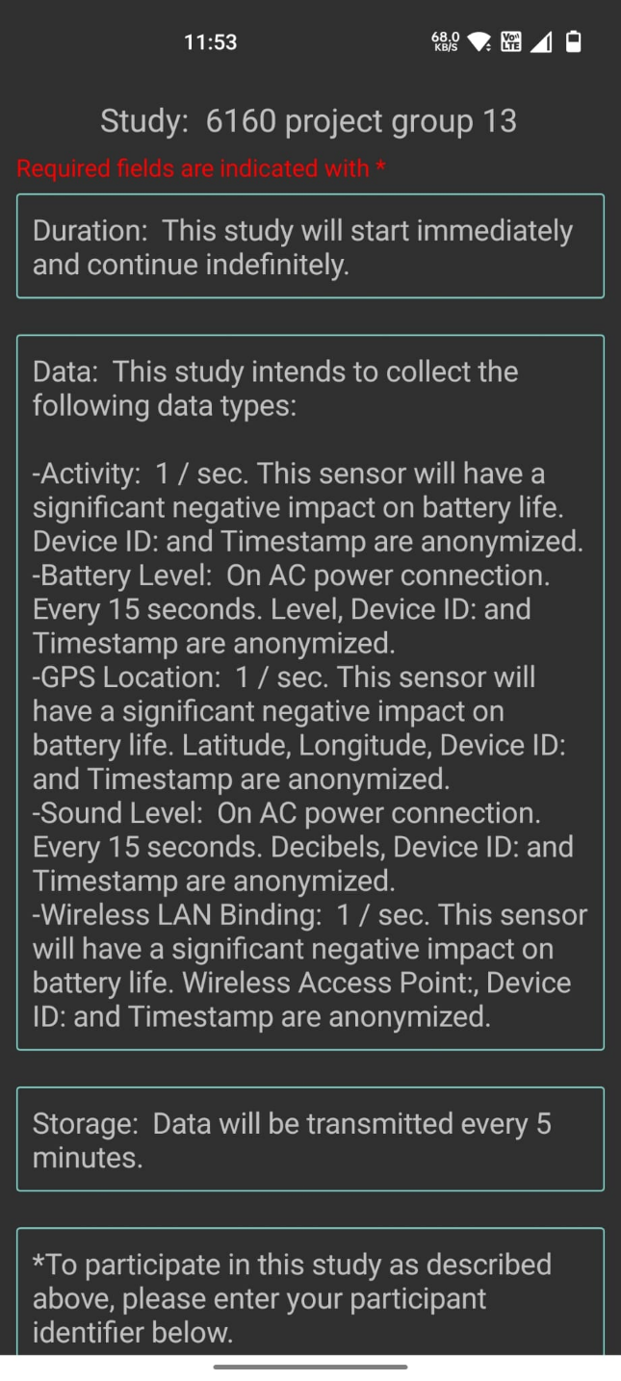

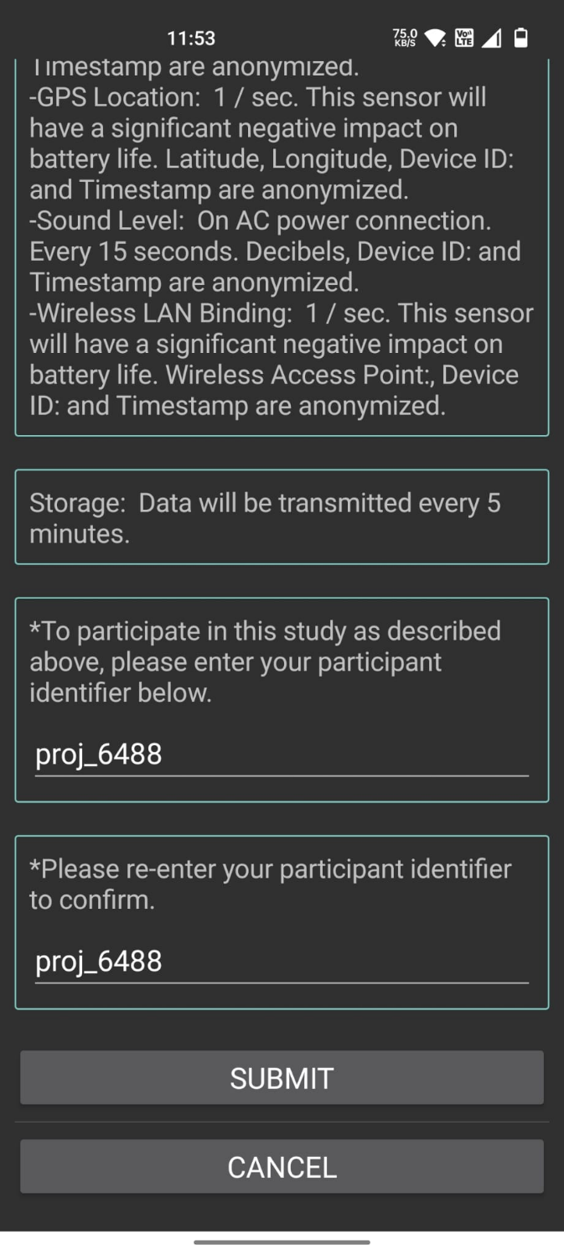

1. Individual contributions:

Himanshi – I have taken initiative to make a s3 cluster for the group. I have downloaded remote data store and aws cli to make it. I have collected the data on sensus app and sent to s3.

Hrushikesh- I have taken the responsibility to make sure the group is on the same line of understanding and on track with any doubts related to sensus app. I make sure all the participants give the data. I have guided all to configure the sensus app and connect it to remote data store. I have also collected data on my phone and sent to s3.

Pavan – I have taken up responsibility to cover the aggregation required after data collection from the Sensus app by importing MySQL. I have discussed with the group all the queries and taken their inputs to write queries.

Chaitanya- I have taken up the responsibility to make sure the report is made with all the visualization techniques and graphs showing the analysis of non relational data. Also , I have ran the python file to download the data from s3. And I have converted it into csv format and sent it to to the group to make aggregation queries.

1. Data summary from each participant

**•device manufacturer-**

Himanshi- Apple

Pavan- OnePlus

Hrushikesh- OnePlus

Chaitanya- Xiaomi

**device model,**

Himanshi- iPhone14,7

Pavan- Nord

Hrushikesh- OnePlusNordCE

Chaitanya- lavender

**operating system ,**

Himanshi- iOS 16.1

Pavan- Android 31

Hrushikesh- Android 31

Chaitanya- Android 29

**device id,**

Himanshi- AA756C5F-EBED-401C-B175-A3838A43A5C8

Pavan- 2b07dc94f4cbd526

Hrushikesh- aa3419f553c924c7

Chaitanya- f8bfd443c11716d6

**participant id**

Himanshi- proj_5595

Pavan- proj_0941

Hrushikesh- proj_6488

Chaitanya- proj_7800

1. aggregation queries and results

-- proj_0941 -> Pavan's device

SET @deviceId = '2b07dc94f4cbd526';

1. First/last timestamps of recorded data

select Min(Formatted_time),max(Formatted_time) from survey_result group by DeviceId having DeviceId=@deviceId;

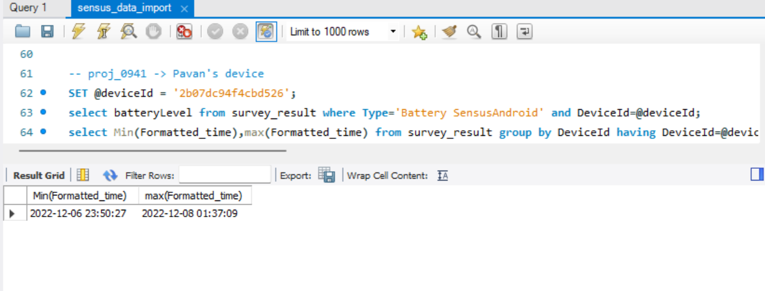

1. Number of records for each probe

select count(*) from survey_result where (Type='Battery' or Type='Battery SensusAndroid') and DeviceId=@deviceId;

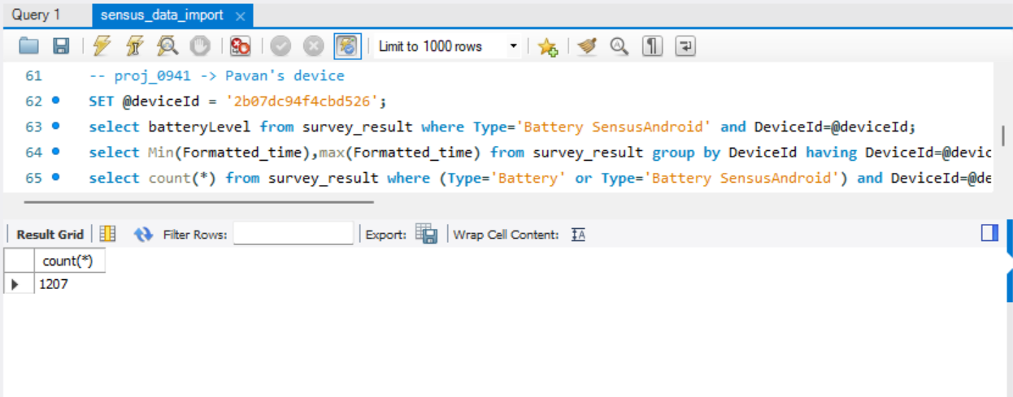

select count(*) from survey_result where (Type='Sound' or Type='Sound SensusAndroid' ) and DeviceId=@deviceId;

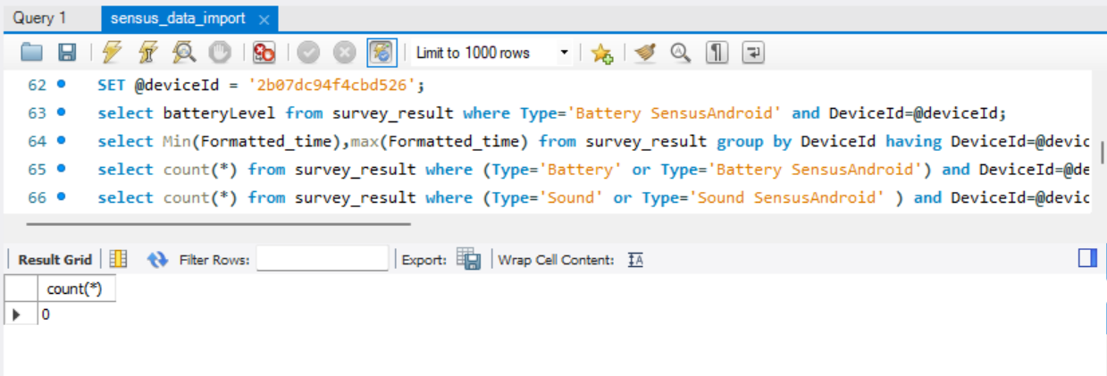

select count(*) from survey_result where (Type='Activity' or Type='Activity SensusAndroid') and DeviceId=@deviceId;

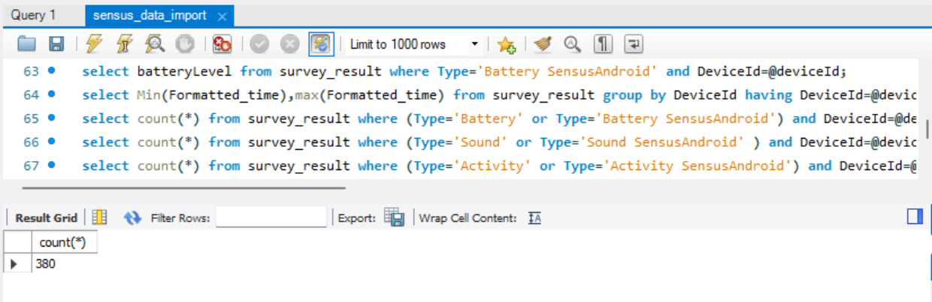

select count(*) from survey_result where (Type='Wlan' or Type='Wlan SensusAndroid') and DeviceId=@deviceId;

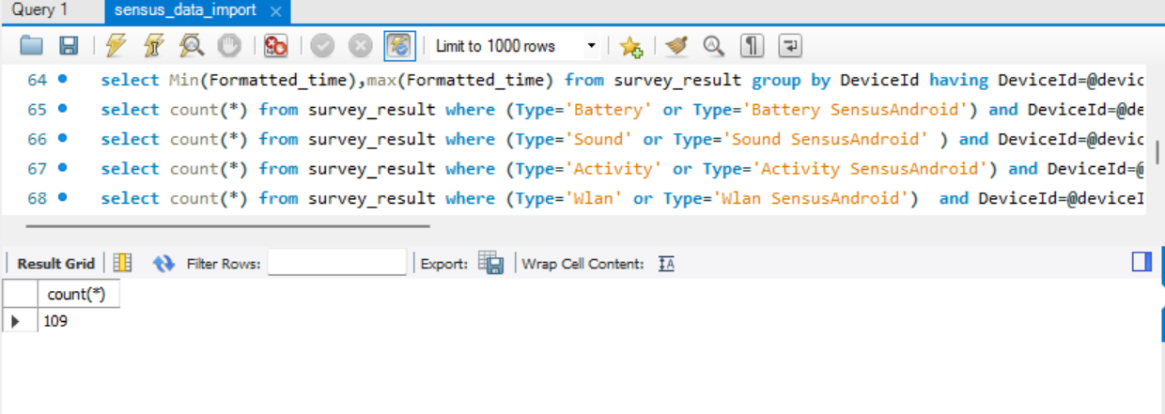

select count(*) from survey_result where Type='Location' or Type='Location SensusAndroid' and DeviceId=@deviceId;

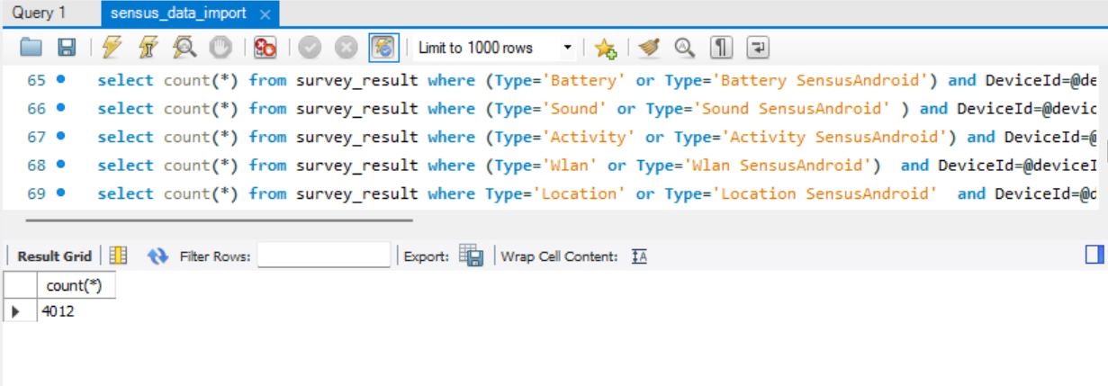

1. Most frequent activity

select count(*) as n, Activity as a from survey_result where DeviceId=@deviceId group by Activity;

create view v as select count(*) as n, Activity as a from survey_result where DeviceId=@deviceId group by Activity;

select a from v where n=(select max(n) from v);

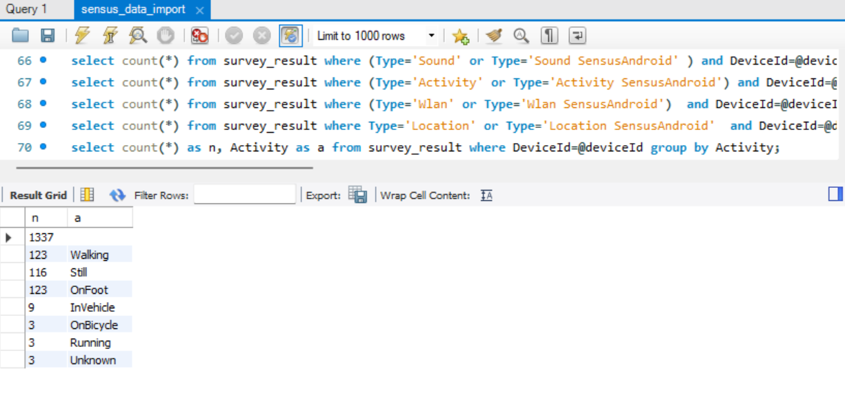

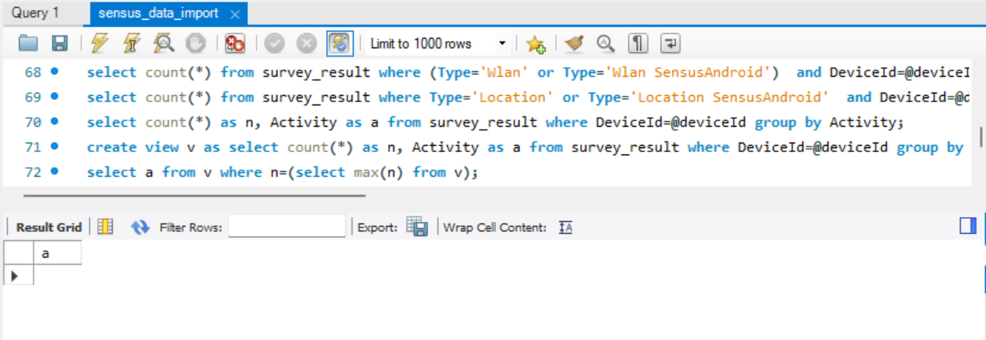

1. History of device battery level

select batteryLevel from survey_result where Type='Battery' and DeviceId=@deviceId;

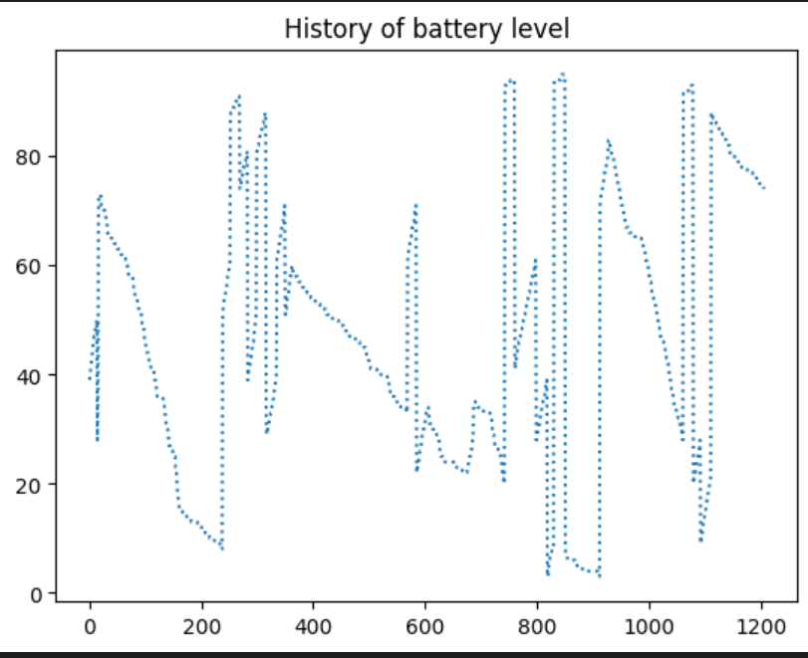

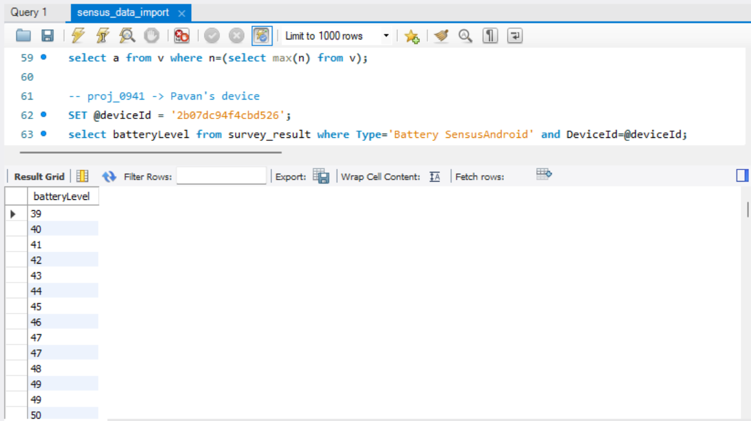

-- proj_5595-> Himanshi's device

SET @deviceId = 'AA756C5F-EBED-401C-B175-A3838A43A5C8';

1. First/last timestamps of recorded data

select Min(Formatted_time),max(Formatted_time) from survey_result group by DeviceId having DeviceId=@deviceId;

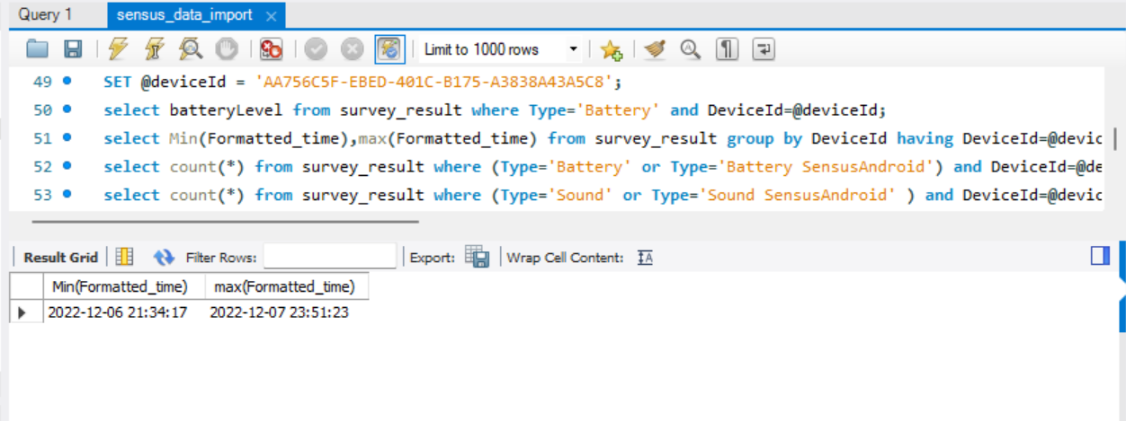

1. Number of records for each probe

select count(*) from survey_result where (Type='Battery' or Type='Battery SensusAndroid') and DeviceId=@deviceId;

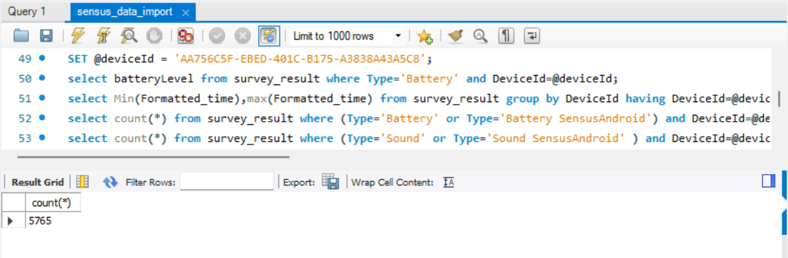

select count(*) from survey_result where (Type='Sound' or Type='Sound SensusAndroid' ) and DeviceId=@deviceId;

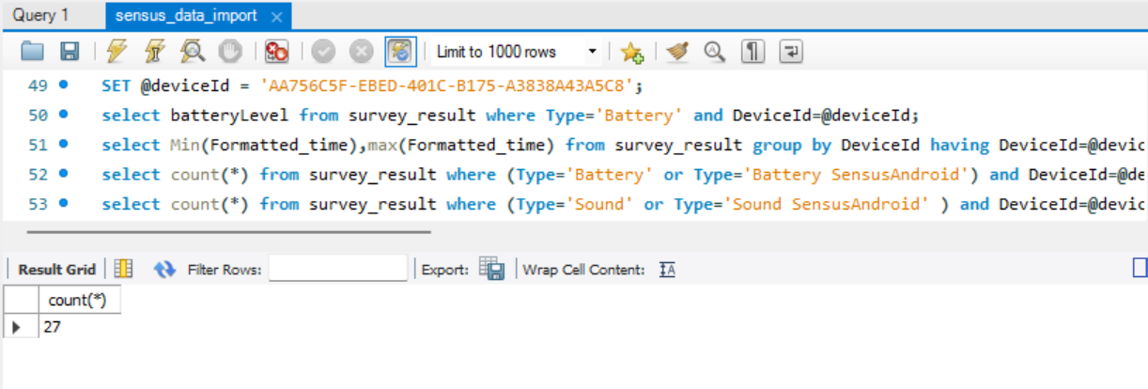

select count(*) from survey_result where (Type='Activity' or Type='Activity SensusAndroid') and DeviceId=@deviceId;

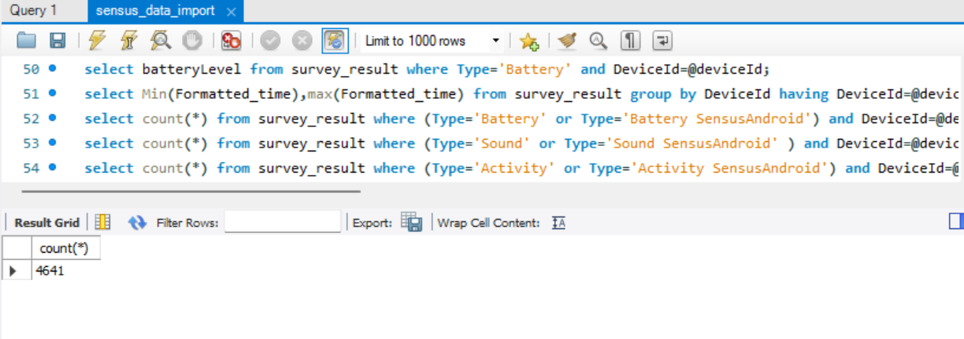

select count(*) from survey_result where (Type='Wlan' or Type='Wlan SensusAndroid') and DeviceId=@deviceId;

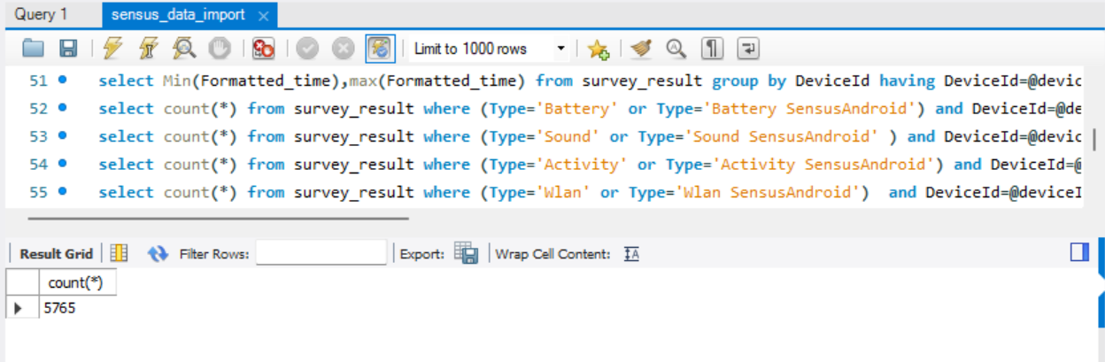

select count(*) from survey_result where Type='Location' or Type='Location SensusAndroid' and DeviceId=@deviceId;

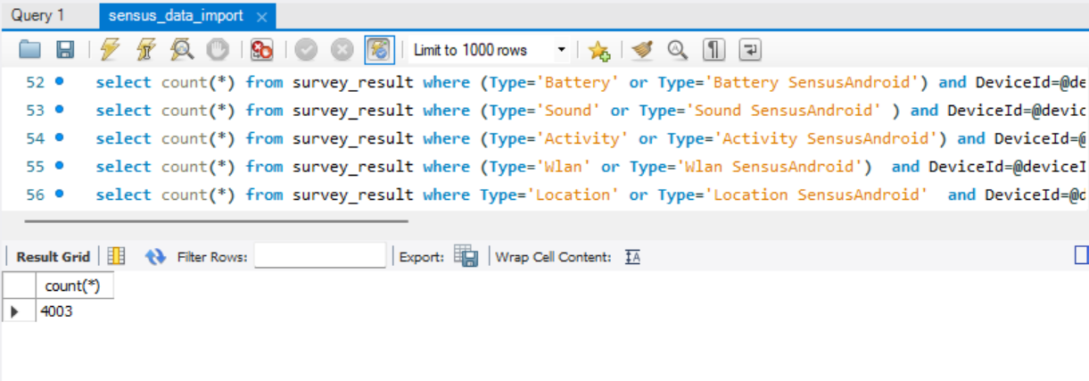

1. Most frequent activity

select count(*) as n, Activity as a from survey_result where DeviceId=@deviceId group by Activity;

create view v as select count(*) as n, Activity as a from survey_result where DeviceId=@deviceId group by Activity;

select a from v where n=(select max(n) from v);

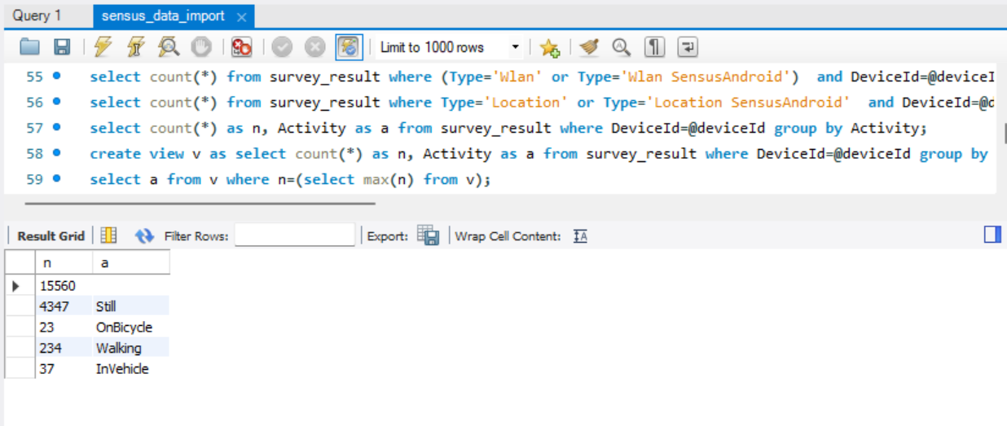

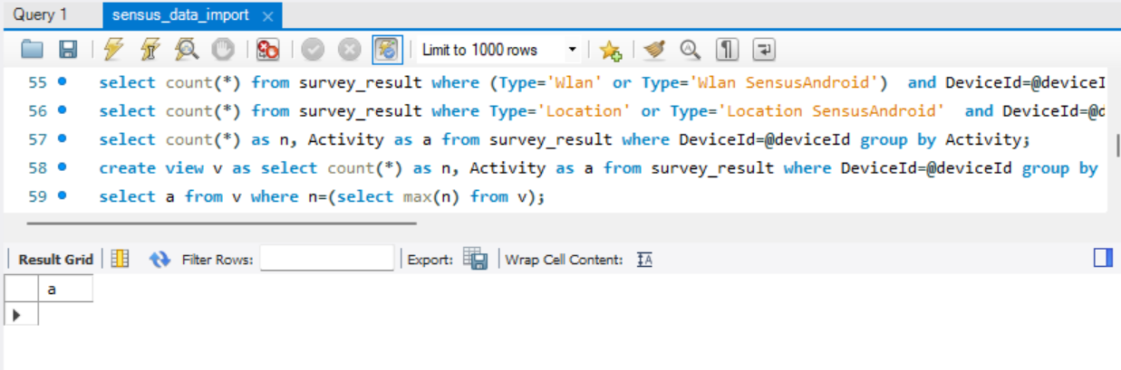

1. History of device battery level

select batteryLevel from survey_result where Type='Battery' and DeviceId=@deviceId;

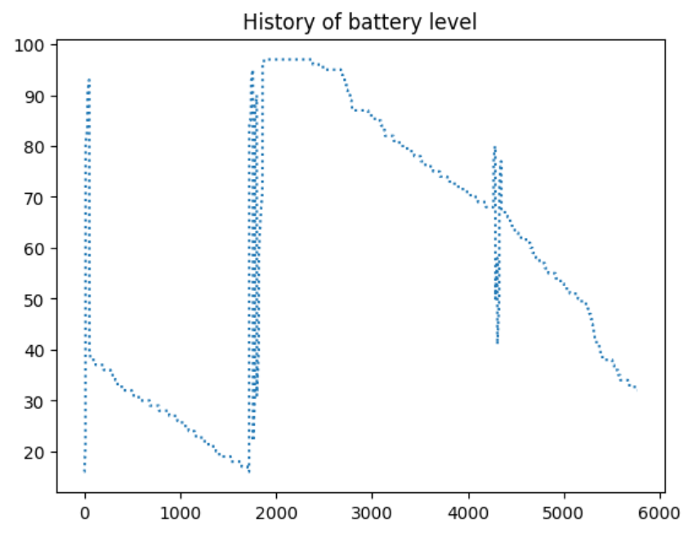

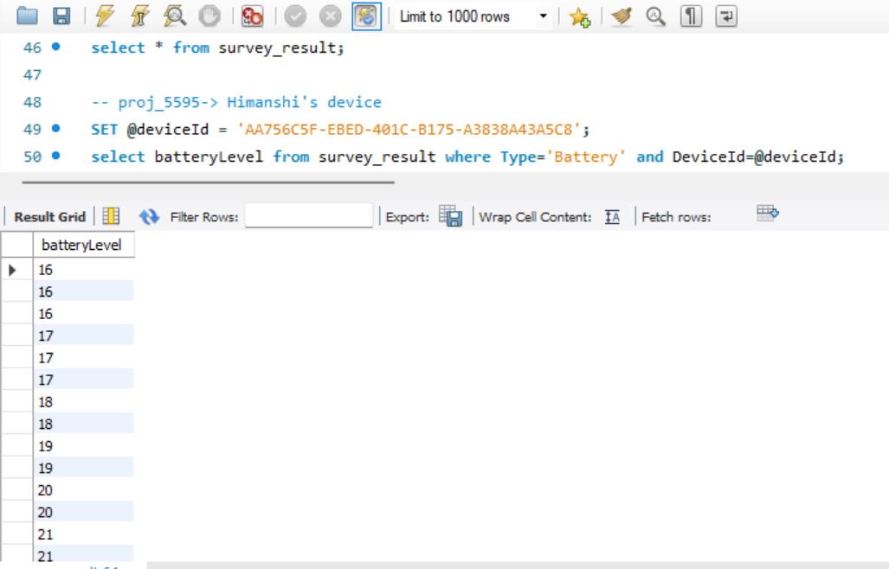

-- proj_6488 -> Hrushikesh's device

SET @participantId = 'proj_6488';

1. First/last timestamps of recorded data

select Min(Formatted_time),max(Formatted_time) from survey_result group by ParticipantId having ParticipantId=@participantId;

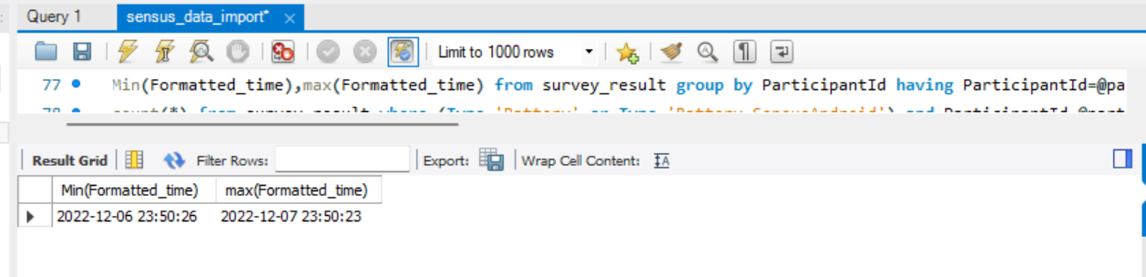

1. Number of records for each probe

select count(*) from survey_result where (Type='Battery' or Type='Battery SensusAndroid') and ParticipantId=@participantId;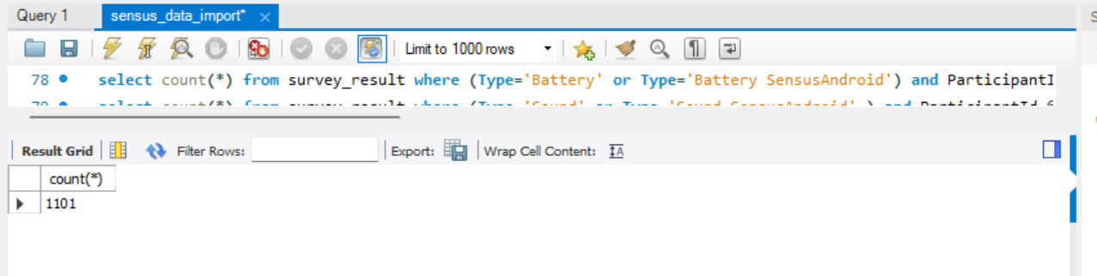

select count(*) from survey_result where (Type='Sound' or Type='Sound SensusAndroid' ) and ParticipantId=@participantId;

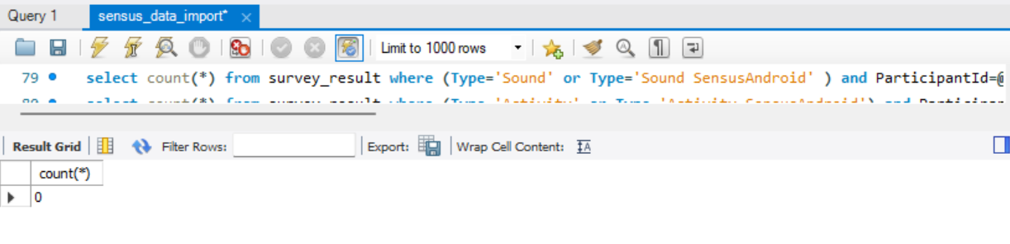

select count(*) from survey_result where (Type='Activity' or Type='Activity SensusAndroid') and ParticipantId=@participantId;

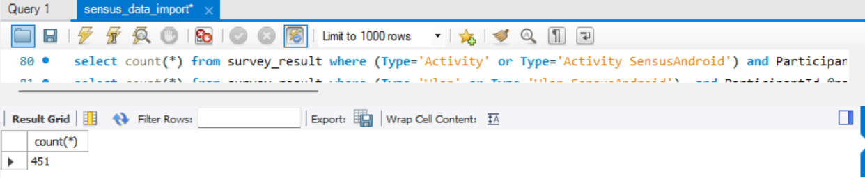

select count(*) from survey_result where (Type='Wlan' or Type='Wlan SensusAndroid') and ParticipantId=@participantId;

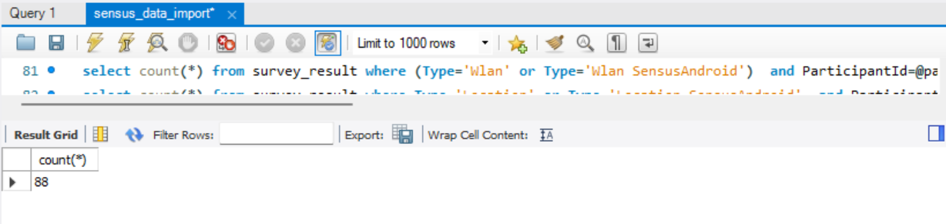

select count(*) from survey_result where Type='Location' or Type='Location SensusAndroid' and ParticipantId=@participantId;

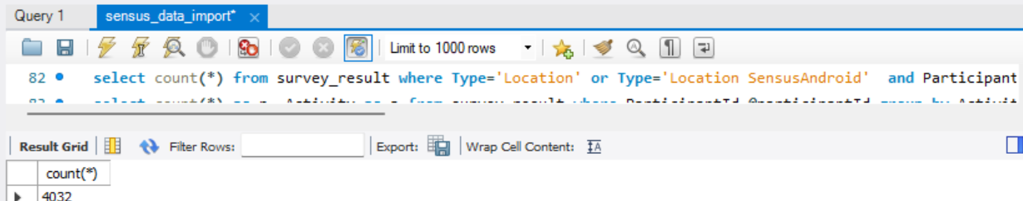

1. Most frequent activity

select count(*) as n, Activity as a from survey_result where ParticipantId=@participantId group by Activity;

create view v as select count(*) as n, Activity as a from survey_result where ParticipantId=@participantId group by Activity;

select a from v where n=(select max(n) from v);

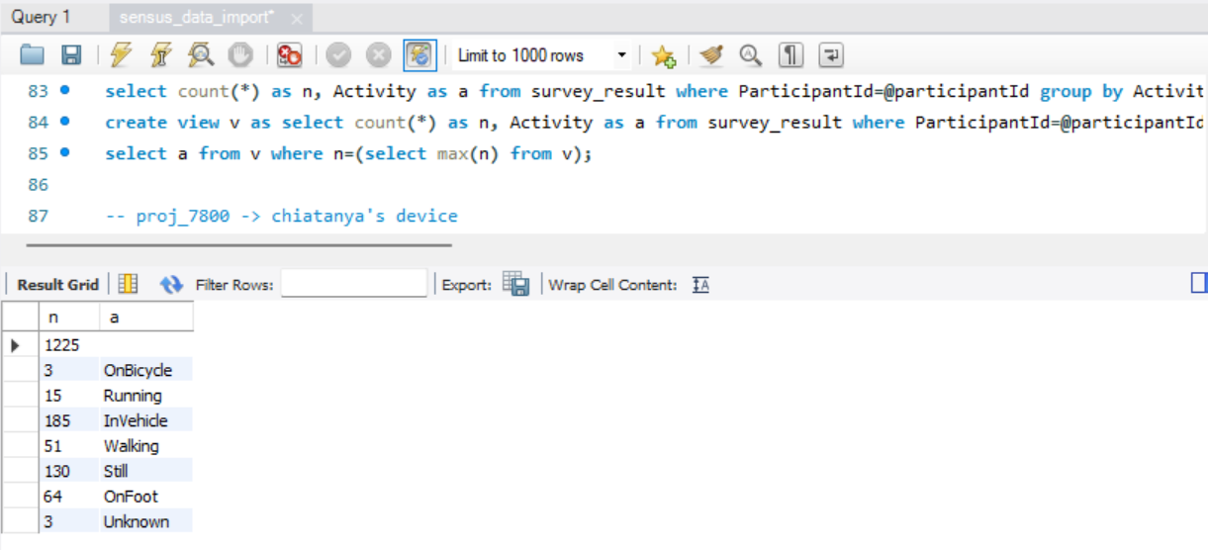

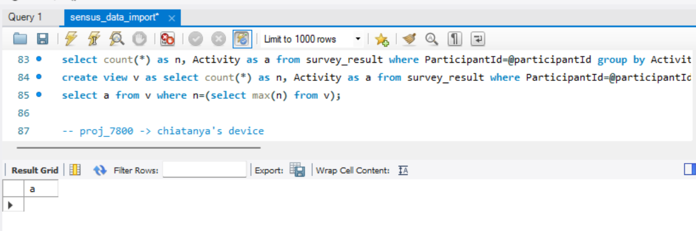

1. History of device battery level

select batteryLevel from survey_result where Type='Battery SensusAndroid' and ParticipantId=@participantId;

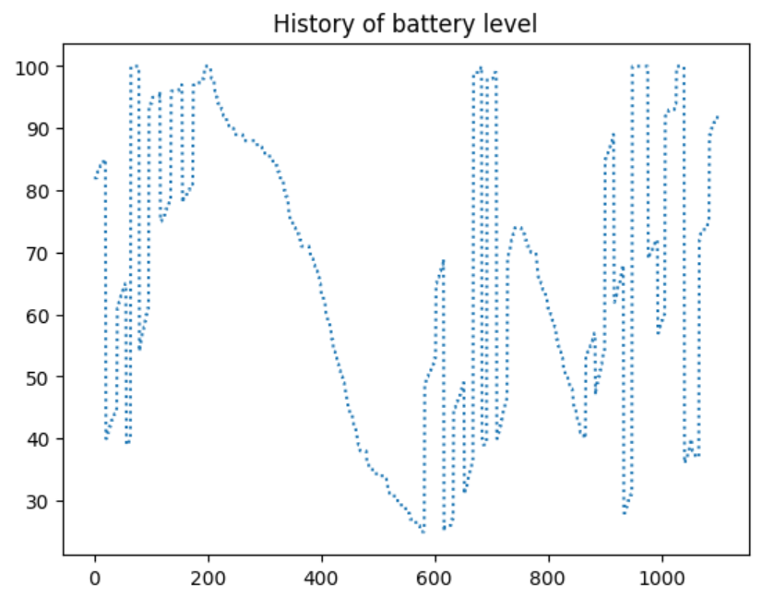

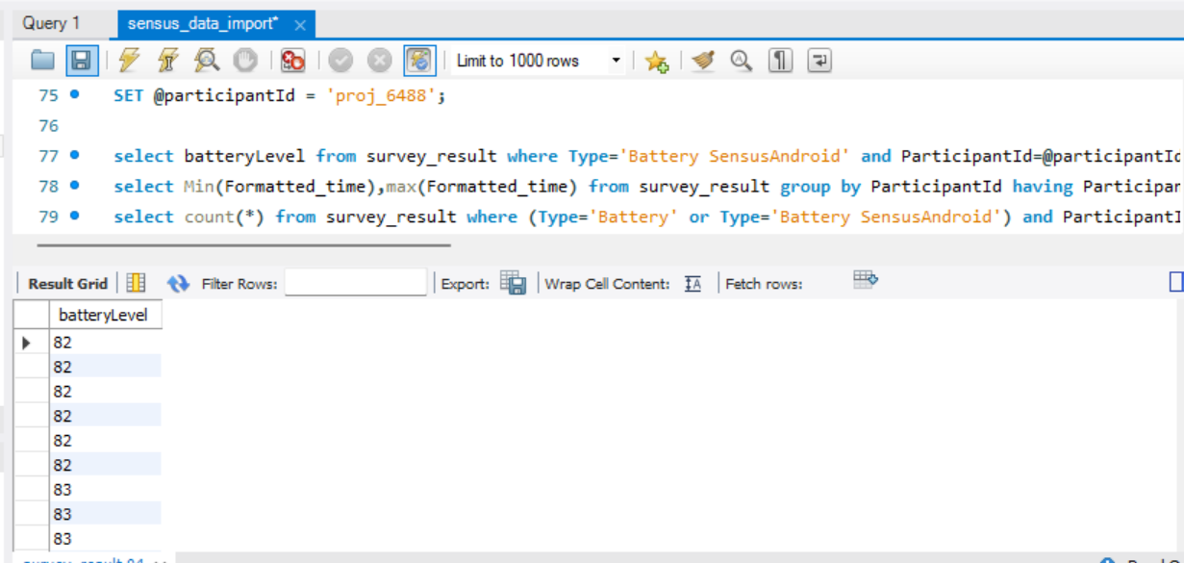

-- proj_6488 -> Chaitanya's device

SET @participantId = 'proj_7800';

1. First/last timestamps of recorded data

select Min(Formatted_time),max(Formatted_time) from survey_result group by ParticipantId having ParticipantId=@participantId;

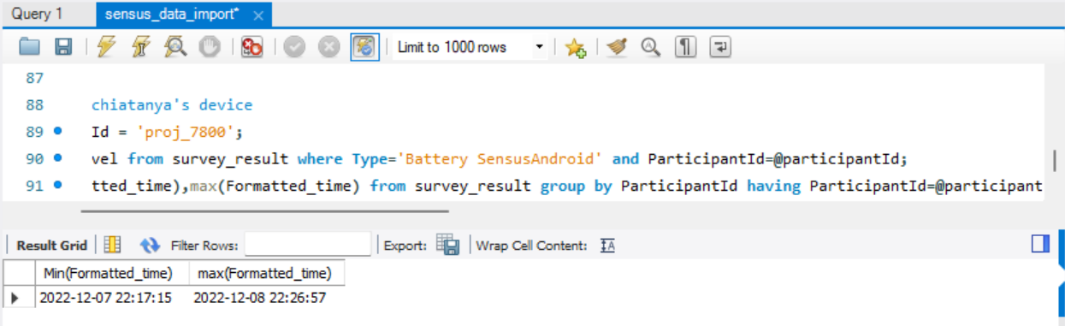

1. Number of records for each probe

select count(*) from survey_result where (Type='Battery' or Type='Battery SensusAndroid') and ParticipantId=@participantId;

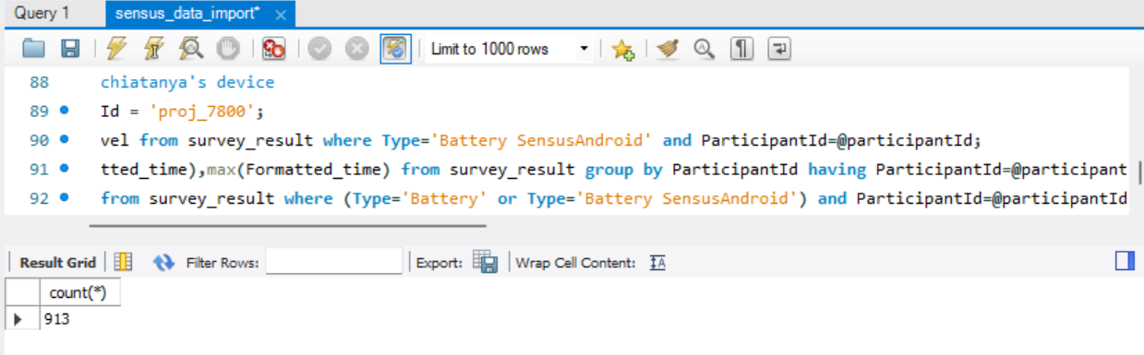

select count(*) from survey_result where (Type='Sound' or Type='Sound SensusAndroid' ) and ParticipantId=@participantId;

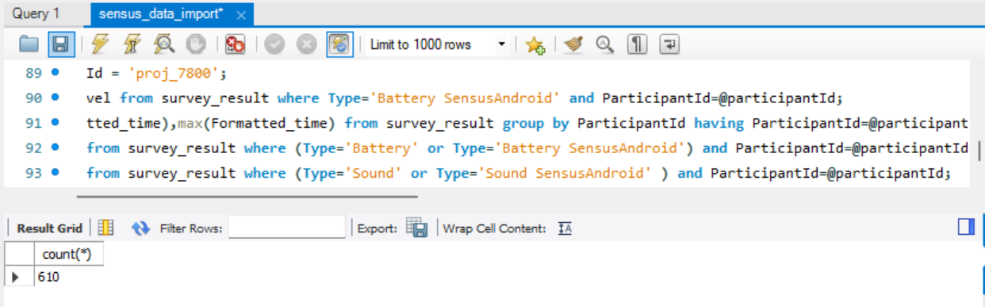

select count(*) from survey_result where (Type='Activity' or Type='Activity SensusAndroid') and ParticipantId=@participantId;

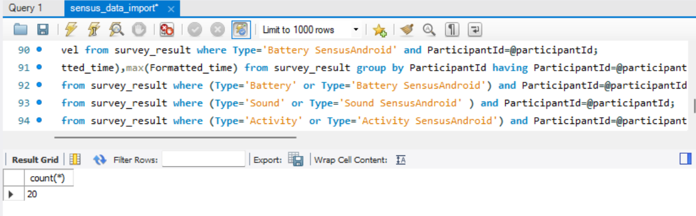

select count(*) from survey_result where (Type='Wlan' or Type='Wlan SensusAndroid') and ParticipantId=@participantId;

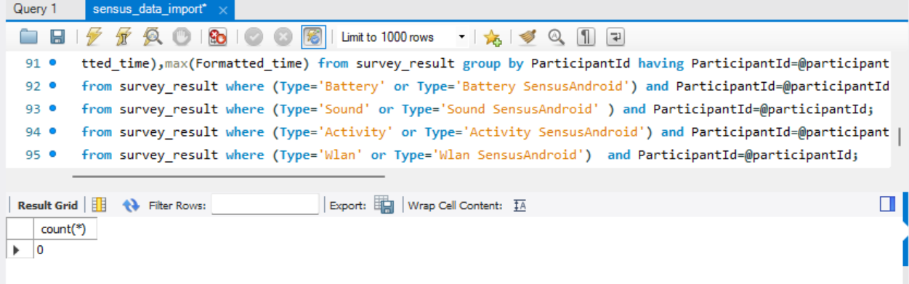

select count(*) from survey_result where Type='Location' or Type='Location SensusAndroid' and ParticipantId=@participantId;

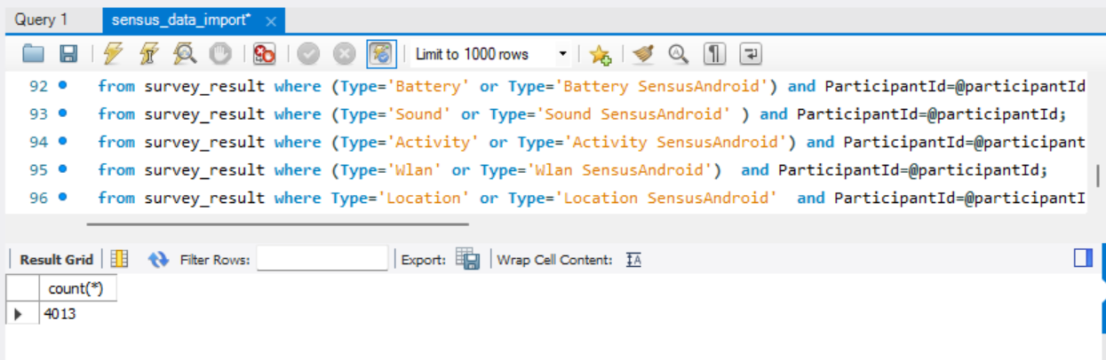

1. Most frequent activity

select count(*) as n, Activity as a from survey_result where ParticipantId=@participantId group by Activity;

create view v as select count(*) as n, Activity as a from survey_result where ParticipantId=@participantId group by Activity;

select a from v where n=(select max(n) from v);

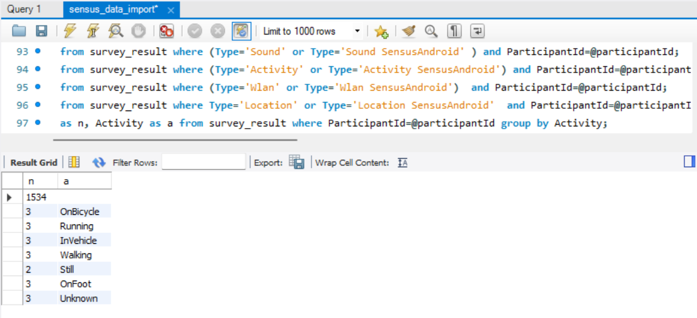

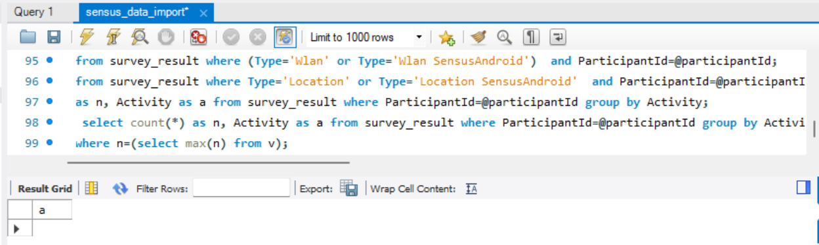

1. History of device battery level

select batteryLevel from survey_result where Type='Battery SensusAndroid' and ParticipantId=@participantId;

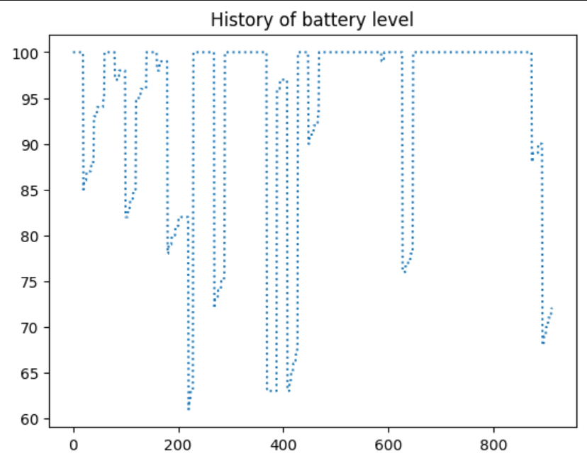

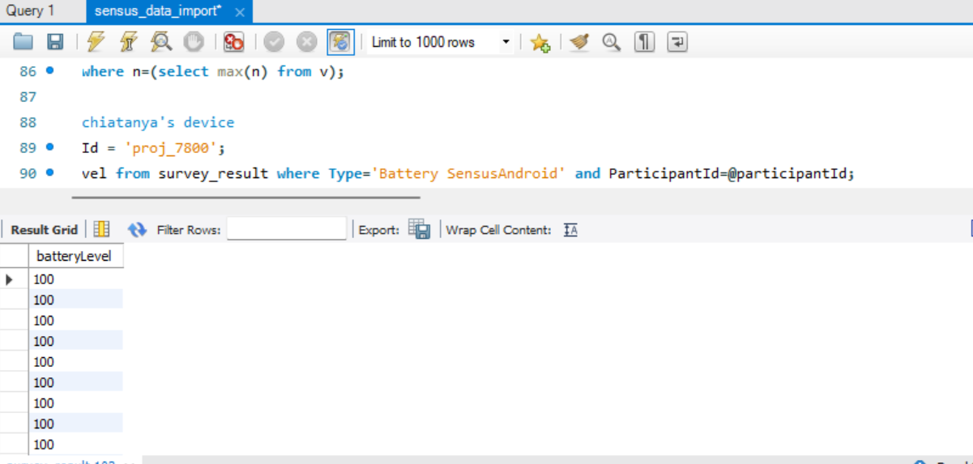

1. **Issues with mobile apps/cloud noted, whether they were resolved, and how (potentially how).**

While working, we found issues like the data was not uploading to s3 even after submitting it after 24 hours. We had to delete incomplete data and upload new again. Also, while using the given code for python to download data, we found that there was issues to use mkdir hence we had to specify the chmod particulary as 0o777. Apart from that, we had difficulty in using my-sql-connector but we resolved it by using my-sql-connector-python. There was also issues in reading json but when we delete the participant folders and try again, it worked fine.

1. **Takeaways and suggestions for improvement**

With project 2, we increased awareness of the creation and use of AWS S3 buckets. Additionally, we learned how to access and modify AWS data files and then process them.

Working in a group was helpful since we were able to thoroughly discuss the project, exchange ideas, and move forward with proper clarity. We also got knowledge on how to work with python to visualize data and to download and use non relational data into csv format.